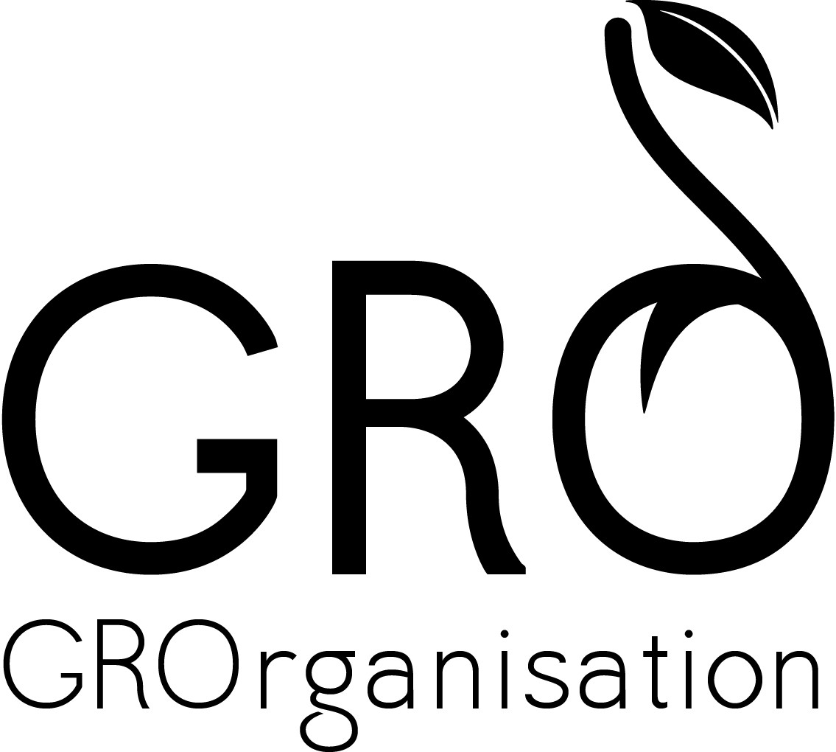
Glasgow Recovery Organisation CIC Café GRO
15 St. Margaret’s Place
Glasgow, G1 5JY
Mobile: 07801842239

Position: Cafe Project Manager
Responsible to: Management Committee
Location: Café GRO
Salary: £25,000 - £26,000
Holiday entitlement: 5 weeks/annum

Background information/ Job Content
Glasgow Recovery Organisation CIC is a Community Interest Company, limited by guarantee. Set up in 2013 by people in recovery from addictions, we wanted to have a space that was alcohol/drug free while providing volunteering, training and employment opportunities for people practicing abstinence based recovery. Café GRO is the result of 2 years of running alcohol free club nights, football tournaments and general slogging away to realise our goal. The café seats 45 people, has a simple menu and, for the right person, is something to put your own stamp on. We are looking for someone who has imagination and flair; who takes pride in whatever they do and is not afraid of challenges. We are open to all but want to create a community café where various activities can take place.
We are an ambitious bunch and want someone who has the same drive and ambition as us.
Through recent funding from The Tudor Trust, London and The Robertson Trust, Glasgow, for a period of 3 years, we are now ready to employ a Café Project Manager. This is a landmark for us. You will be our first employee and will be working closely with one of our Directors. We are in the proceeds of funding for a further 4 staff and will be offering volunteer placements in the café.

Purpose of the Job:
To manage the operation and development of a new Social Enterprise Cafe set up by Glasgow Recovery Organisation CIC, including budget planning and management, marketing design and development, and the management and development of staff, in order to :
- create volunteering, training and employment opportunities for people in recovery from addictions where they will receive appropriate training and support for them to get the maximum benefit from working at Café GRO.
- make best use of resources to show strong sales growth and achieve excellent commercial margins, whilst meeting the required standards within the café.
- create a range of activities and workshops that will benefit community development.
Duties:
To have overall responsibility for the production and planning of the café, food and service development and quality standards and presentation.
To have overall responsibility for, and to assist in, assessing training needs of volunteers and staff, overseeing training plans and ensure accurate records are maintained throughout.
To design and implement a marketing strategy that will develop the Café’s reputation for good food, and achieve strong sales growth to support the project and the Organisations wider objectives.
To work towards sustainability of the businesses by active participation in marketing and developing new ideas.

To identify staff training needs in the cafe and deliver training as and when required.

To be hands on in the operation of the service.
To plan budgets for the cafe, including food costs and margins, for approval by the Management Committee.
To monitor achievements of budget costs and report to the Management Committee on any variances against budget, including proposals for action to address these
To improve the café project profile on the Glasgow Recovery Organisation website, regularly maintain it and make use of social media e.g. Facebook and twitter on a daily basis.

To plan menus in accordance with purchasing procedures, taking account of seasonally, freshness of product and demonstrate an awareness of general food trends.
To monitor purchasing, ensuring satisfaction in price and quality.
To ensure that all financial records are correctly maintained, including stock control and cash reconciliation.

To ensure effective stock rotation and organise a supervision programme of monthly stocktaking.
To ensure that premises & equipment are maintained and operated by statutory and local authority food safety and health & safety legislation and regulations.
To monitor all activities in line with HACCP and maintain records required for HACCP purposes in all areas of the businesses.
To ensure all staff and volunteers are appropriately trained and operate within food safety and health & safety regulations and legal requirements.
To develop a staff and volunteer training plan for café and record and monitor training needs. This should include induction, legal requirements and customer service. Mentoring and development of staff and volunteers should be included in this plan.
Annual appraisal meetings and reports are the responsibility of the job-holder but are reviewed and signed off by the Management Committee; further stages of any grievance and disciplinary procedure are carried out by the Management Committee. Only the Management Committee may authorise dismissal.
To be responsible for any other relevant duties as directed by the Management Committee.
Responsible for:
The post holder will be responsible for the management of all staff and volunteers in the cafe, including day to day support and supervision, conducting annual appraisals, and for the initial stages of any grievance or disciplinary procedures.
Support & Supervision:
From the Management Committee on a regular basis.
PERSON SPECIFICATION
Essential:
- At least 3 years of working as a Chef
- Ability to motivate and support staff
- Strong Leadership Skills
- A minimum of 3 years’ experience in a management role within a catering establishment
- An HND or similar in a relevant discipline
- Food safety training to minimum of intermediate
- Excellent IT skills
- A commitment to the core aims of the organisation
- Report writing experience
- Clean current driving licence
- Effective communication skills at all levels
- Ability to positively lead a small team
- Flexibility in relation to working hours

Desirable:
- Experience of working in new business start-up
- Budget management experience
- Training experience
- An understanding of the challenges faced for people in recovery from addictions
- Ability to work with limited resources
- Experience of working within a Social Enterprise
- Experience of working with Volunteers
- Experience of community development
- Car owner

