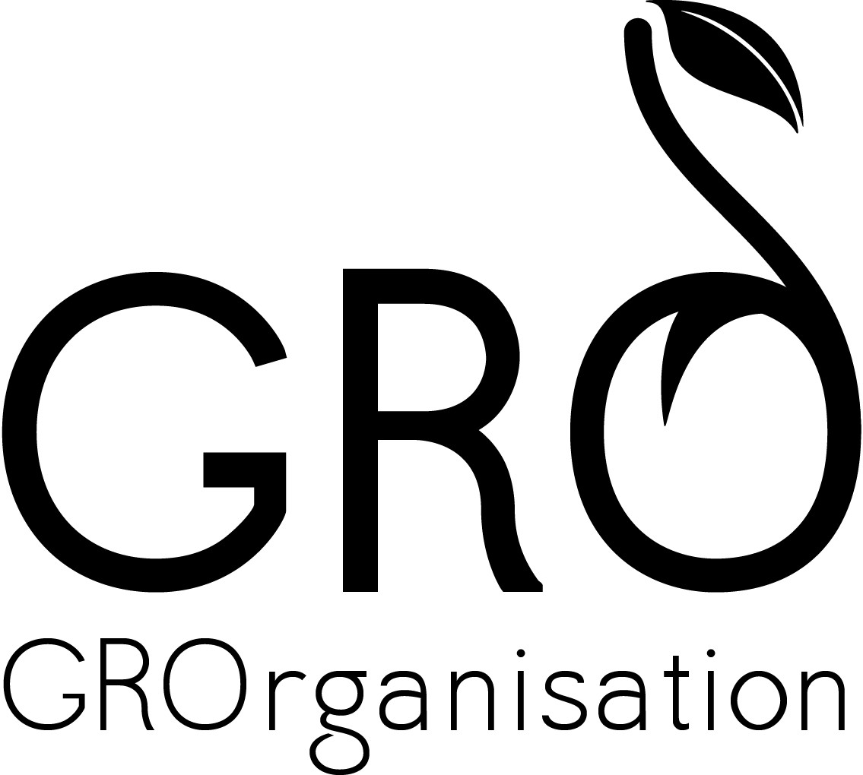

Glasgow Recovery Organisation CIC Café GRO

15 St. Margaret’s Place

Glasgow, G1 5JY

Mobile: 07801842239

October 2015

Dear Applicant

Catering Project Manager

Thank you for your interest in the above post.

Please complete the application form, and an equal opportunities form and email back to me at info@glasgowrecoveryorganisation.org

You should have also downloaded a job description and person specification which you need to read thoroughly before applying.

We look forward to receiving your completed application, with a covering letter, by Thursday 5th November 2015.

Interviews for the post will be held on 16th November 2015

If you require any further information please contact Donna Campbell 07801842239

We look forward to receiving your completed application and supporting documents. We will accept CVs but you must also complete the application form.

Best wishes

Donna Campbell
Founder Director

